Automation Testing User guide

Prepared By:
Mridula Seviliemdu Veravalli



ABOUT THIS DOCUMENT
Purpose
The purpose of this document is to explain the test automation structure used for regression testing and to guide the user through the steps in order to successfully execute the automated scripts.
Intended Audience
This document is intended to be used by:
- QA Manager
- QA Lead
- BA Lead

Document Revision

Version | Revised Date | Change Description | Revision by
1.0 | 12/19/2014 | Initial Document
1.1 | 2/09/2015 | Revised and updated Document | Jithin Mony
2.0 | 6/26/2015 | Revised and updated Document | Jithin Mony
3.0 | 01/05/2017 | Revised and updated Document | Mridula Sevilimedu Veravalli
CONTENTS
ABOUT THIS DOCUMENT 1
1.0 Introduction 5
1.1 Overview 5
2.0 Automated Products & Coverages 6
2.1 Products available in Automation (In Scope) 6
2.2 Functions / Features Excluded from Automation Testing (Out of Scope) 6
3.0 Diagrams and Automation Components 3
3.1 UFT Automation and Data Driven Framework 3
3.2 Automation Components and Links 4
3.2.1 Server Machine - 2UA2011D7K 4
3.2.1.1 CRAFT 2.0 server 4
3.2.2 Client Machine - 2UA2180KBD/2UA2380HFV 5
3.2.2.1 CRAFT 2.0 Agent (Client) 5
3.2.2.2 Unified Functional Test (UFT) 6
3.2.2.3 CRAFT Data- Driven Framework 6
3.2.2.4 Task Scheduler 7
3.2.2.5 Caffeine 9
4.0 Test Execution 9
4.1 CRAFT Based Execution Steps 9
4.2 Stand Alone Automated Healthcheck 10
5.0 Maintenance & Good Practices 10
5.1 Creating New Scripts 10
6.0 Lessons Learned 11
7.0 All Links 11
8.0 Signatures & Authorization 12

1.0 Introduction

Overview
Automation testing in HFP is broken up into two types:

    - CRAFT based automation suite

All of the automated test products are available in this suite. These tests are executed during the regression testing phase in the project lifecycle. The tester will initiate the tests from the CRAFT 2.0 machine and the tests will execute on the machine running UFT. The run results are then passed back to CRAFT 2.0 machine where it can then be viewed by the tester.

    - Standalone daily health check suite

These are the scheduled tests that are run on a daily basis. The goal of these tests is to ensure the test applications and products are available and working as expected in Production and Training environments. These are scheduled tests that start on their own every morning and the results are reported to the stakeholders via email.

2.0 Automated Products & Coverages

2.1 Products available in Automation (In Scope)
Most of the products and coverages that we offer have been automated and included in the scripts. The automated testing covers- End to End flows of products, supported coverages, premium validations, and rating factor validations.

List of products covered:

Vision Products:
- Private Choice Premier
- Crime Shield Advance First Party
- Crime Shield Third party
- TechE&O
- TechE&O -New
- Ovation
- AMC
- Cyber
- Healthcare
- Hartford Professional Liability
- DirectorsAndOfficers
- IAERISA
- CyberFirstResponse

SBU Pronto Products:
- MMEL
- Crime Shield Third Party
- Cyber
- TLSP
- IAERISA

Functionalities include: End to End flow, premium verification, endorsement verification, quote Letter Verification,forms displayed in quote page Verfication, bind Letter Verification,forms displayed in biner page Verfication Print Email Policy functionality,
E-signature, and Re-rating

2.2 Functions / Features Excluded from Automation Testing (Out of Scope)

Functionalities that are currently Out of Scope includes, but are not limited to:
Form content

3.0 Diagrams and Automation Components

3.1 UFT Automation and Data Driven Framework

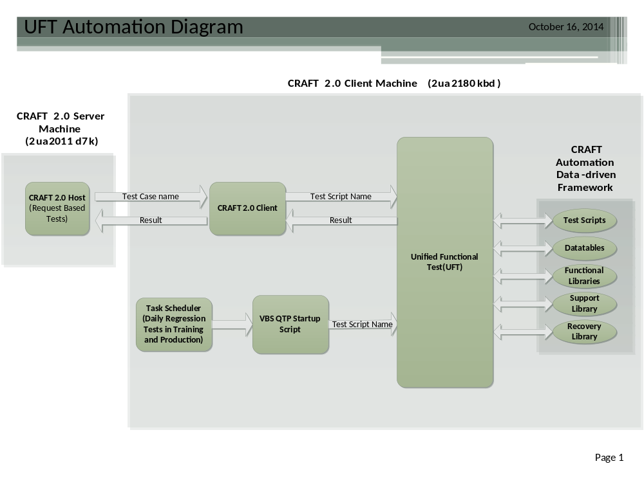

  - Automation Components and Links

3.2.1 Server Machine - 2UA2011D7K

3.2.1.1 CRAFT 2.0 server
- Summary
This is the server that is hosted on the IIS of machine 2UA2011D7K. This tool is used to execute the CRAFT based automated suite tests. All of the currently automated tests can be found within this tool and these tests have been mapped to the corresponding scripts in UFT.
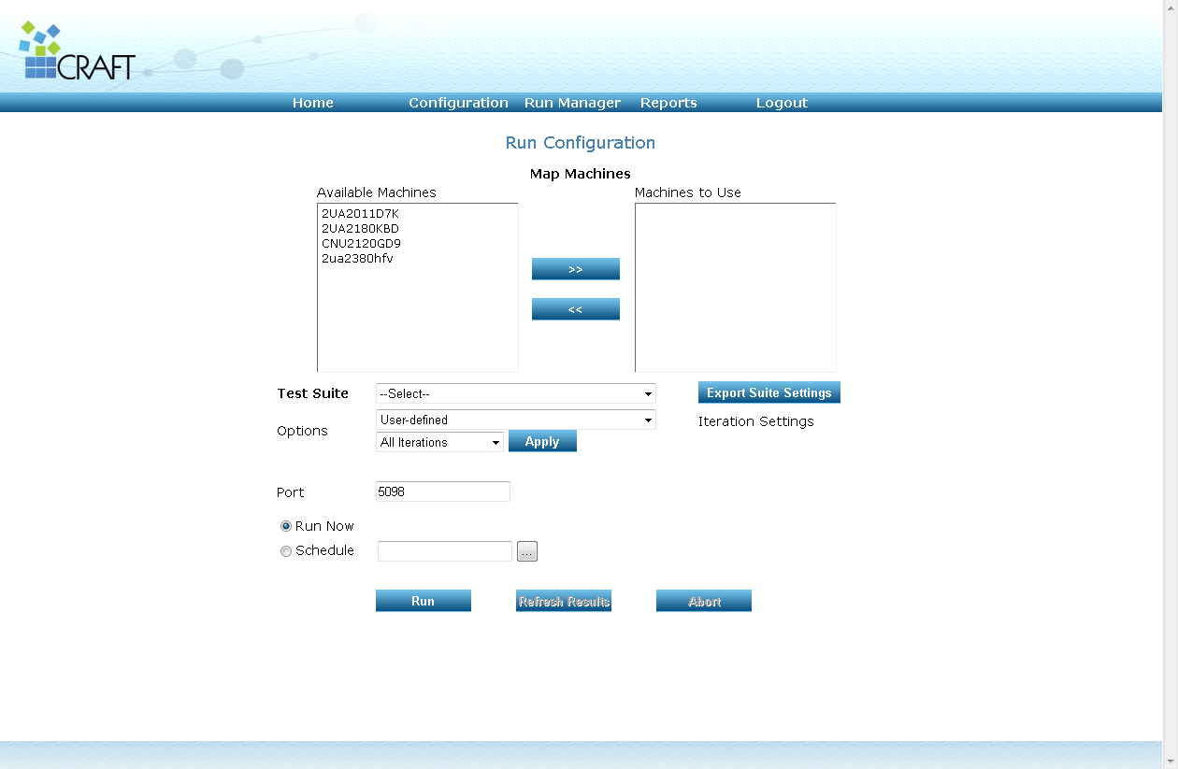

- Login
When logging in from the server machine, the link to access CRAFT is
<<http://localhost/CRAFT20Web/Login.aspx>>
For ease of use, the CRAFT 2.0 tool can be accessed from any machine on the network. When doing this just replace the ‘localhost’ portion within the link with the IP address of the server machine.
For example:
<<http://10.154.252.81/CRAFT20Web/Login.aspx>>

Upon accessing the link, users will be presented with the login page. The login credentials are:
Project- vision
Password- vision123

- Executing Scripts
Once logged in, click on the Run Manager Tab. Select execute suite option from the drop down. This presents the user with the Run Configuration screen. Select the client machine (2UA2180KBD/2UA2380HFV) from the list of machines available. Then choose the test suite from the drop down list. At this point, make sure that the CRAFT 2.0 Client is enabled on the client machine. The server machine is now ready to pass the test details over to the client machine. The client machine will execute the test and send the result back to the server machine. Select the tests you wish to execute and press run to start the execution.

3.2.2 Client Machine - 2UA2180KBD/2UA2380HFV

3.2.2.1 CRAFT 2.0 Agent (Client)
- Summary
Craft 2.0 Agent should be open and active on the client machine when testing from the CRAFT based automation suite. This tool allows for communication between the server machine and client machine. Once started, the tool can receive the test information from the server and pass it to UFT and pass the end results from UFT to the server.
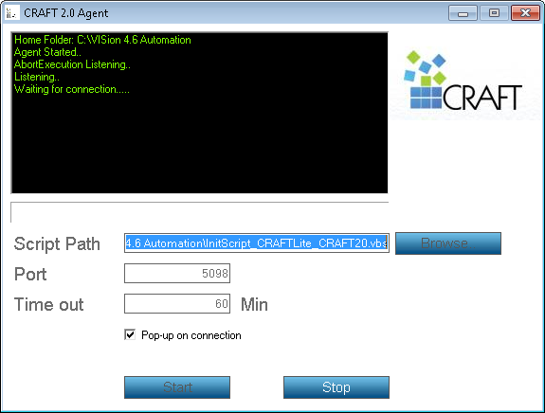

- Starting CRAFT 2.0 Agent
The CRAFT Agent icon can be located on the taskbar on the client machine. Opening this brings up the Agent screen and automatically starts the listening process. The listening process can be manually started by clicking start. Clicking stop will abort the listening. Once opened and active, this tool can be run minimized in the taskbar for convenience. It is important to only have one instance of this tool running at any given time. Having more than one instance open will cause the agent to disconnect. This will result in an error message.

CRAFT 2.0 Installation Document for Reference
N:\@QTPAutomationScripts\VISion 4.6 Automation\Craft 2.0 Tool\CRAFT20\CRAFT 2.0 - Installation_Guide.doc

3.2.2.2 Unified Functional Test (UFT)

Summary
The Unified Functional Test is the newer version of the well-known Quick Test Professional by HP. This is the automation tool currently being used by HFP. This tool is installed on both the server machine and the client machine.

3.2.2.3 CRAFT Data- Driven Framework

- Summary
The Craft Data driven Framework consists of Test Scripts, Datatables, Functional Libraries, Support Libraries, Recovery Libraries. The combination of all the above items creates the framework.

- Test Scripts
This is the actual action file or the main file for the script. Every product that has been automated has its own test script. The test script defines the flow of the test and is typically organized by the pages in the end to end flow of the product. Each test script is associated with an object repository, datatable, functional library, recovery library, and support library.

- Datatables
Datatables are used to hold the data that are passed into the test fields during execution. This data can be hard coded in the script or kept separately in excel datatables. The benefit to having the data in a datatable is that the data is dynamic and can be easily changed as needed. This makes the test more re-usable and scalable. Each of the products have their own datatable. Each row in the table is mapped to a particular iteration/test case in CRAFT 2.0 server.

- Functional Libraries
Libraries contain many different functions that are called by the UFT. These functions are mostly organized based on the web pages. Each page will have a function associated with it. When a test is running, it calls upon these functions to handle individual aspects of the test. For example- If the premium is being verified, a premium verification function will be called to validate the premium. These functions are placed into libraries called business functions. Each test script will have a functional library and the functional libraries maybe shared between test scripts if they contain common functionalities.

- Recovery Libraries & Support Libraries
Similar to functional libraries, these libraries also handle specific tasks within the test. Recovery Libraries are used for error handling and contains various functions that can be used to recover from error states. This library is common and is shared with all test scripts.

3.2.2.4 Task Scheduler
- Summary
This is a tool that was created to allow scheduling of test scripts. Each of the health checks have a startup script associated with it. These scripts are located at this location on the client machine.
<<C:\VISion 4.6 Automation\NO CRAFT QA Testing Scripts>>
Upon opening the startup script for a product, UFT is called and the test run for that product is started. These start-up scripts are scheduled using the task scheduler to run every morning. The Task Scheduler application can also be found at the same location.

Task Scheduler is a home brewed application created by HFP employee Tran Oai. He may be reached for any additional support or troubleshooting with this application.
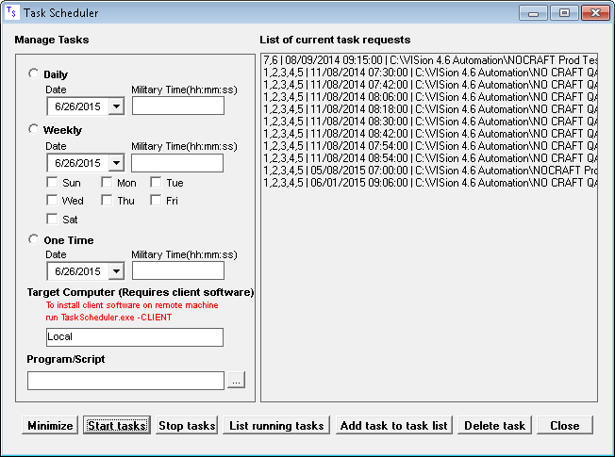

- Scheduling Tasks
When opened, the user is displayed with the currently added tasks on the right, the scheduling options on the left, and all the action buttons on the bottom. The ‘List running tasks’ button will display all the tasks that are currently scheduled. If no tasks are scheduled, the user can schedule tasks using the start tasks button. Clicking ‘Start Tasks’ button schedules the tasks added and shown on the right side of the app. This also minimizes the app for un-interrupted testing Whenever Tasks are scheduled for the daily healthcheck it is important to have caffeine running to avoid the machine from locking or logging off due to system idle time. You can see details on running Caffeine in section 3.2.2.5.

- Viewing results
Upon completion of a scheduled task, the results are not emailed out immediately. The results are held in a .doc file until all the tasks are complete. The last task emails the results from the .doc file to the QA team. This folder is kept at this location.
N:\@QTPAutomationScripts\VISion 4.6 Automation\QATrainig_Results

3.2.2.5 Caffeine
- Summary
Caffeine is a tool that prevents your PC from sleeping, locking or activating the screen saver. It does this by emulating a key press at preset intervals of time so that it makes the windows think the session is active and not idle.

- Turning on Caffeine
Caffeine is located at the root location of C: drive. To run caffeine, use the command prompt. Change directory to C: drive and type in the following:

Caffeine.exe –useshift
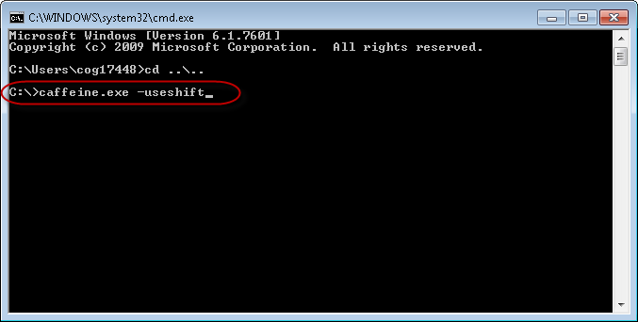

This will enable Caffeine and run in the mode which emulates a shift key press every 2 minutes. The caffeine icon, circled in red below, will indicate that caffeine is active.
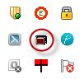

4.0 Test Execution

  - CRAFT Based Execution Steps

Listed here are the steps to execute test cases from CRAFT 2.0.
- Enable Caffeine on the Client machine
- Turn on the CRAFT agent on the Client machine.
- Access the CRAFT 2.0 on the Server machine and go to Execute Test.
- Choose the client machine from the list and select test cases to be executed.
- Click Run
- Test Run will start on Client machine and UFT will run test.
- Once run is complete, results will be available on the server for viewing.

  - Stand Alone Automated Healthcheck

Listed here are the steps to schedule a test in the task scheduler.
- In task scheduler, choose time and scripts to execute.
- Add task to list and then schedule the task.
- Task will automatically start up at the scheduled time.
- Results are stored in .doc file for later access and email trigger task.

5.0 Maintenance & Good Practices

5.1 Creating New Scripts

This section outlines the steps to be followed when automating a new product or creating a new test script.
- Anlayze the new product to see if we can re-use the script from any existing Products. If new product is similar to an existing product, then the existing product is a good starting point. This will minimize re-work needed.
- If new product is in Vision, then AMC product script can be re-used and modified to create the new script. If new product is in SBU Pronto, then Pronto Cyber can be used.
- In Vision, most products have the same work flow. The only pages that differ are underwriting worksheet and Rating Summary. Other pages such as Clearance, Account Summary, Quote, Binder, Book/Bill, and Issue pages are shared between all Vision Products.
- Similarly in Pronto, the initial pages such as the Login EBC, Create Submission and Choose Product pages will be the same across all SBU products. Aside from the initial pages all Pronto products are very different from each other.
- Each product will need its own datatable with excel tabs broken up into different pages within the application. Again, its best to change around an existing datatable of a similar product. The corresponding datatable tab needs to be imported and called at the start of each page.
- For Object Identification, we can use descriptive programming or the Object Repository. For Vision products, associate “Vision_Rep.tsr” to the test. This repository has the objects from all the common Vision pages already created. To handle the objects in unique pages, descriptive programming is the quickest and easiest approach. Similarly for SBU Pronto products, associate the “SBU.tsr” for the common pages.
- Since each page is handled as a different function, new funtions need to be created for the product. These funtions can be defined in the test script itself or in an associated business function. For Vision products, use “Business funtions.qfl” and for SBU Pronto prducts use “SBUTestingFuntions.qfl”
- Once the test has been created, it to the CRAFT application. This can be done as bulk or individually. To do this individually, test cases can be created from the configuration tab on the CRAFT application and added to their corresponding test scenarios. To do this in bulk, use the Bulk import field feature. The excel sheets used for bulk importing are maintined at the below location.

N:\@QTPAutomationScripts\VISion 4.6 Automation\CRAFT20 Bulk Import Table
- Add the created test to a test suite in CRAFT and match up the iteration number in CRAFT with the test row in the datatable. Then enable the CRAFT agent and the test should be ready for execution.

6.0 Lessons Learned

- Craft & Daily regression results clean up.
- Take Back up of Scripts amd Results folder every month.
- Update new scripts/Test cases to Bulk import excel sheet.
- Delete the Results folder in Share drive every 3 months.

7.0 All Links

All referenced Links

- CRAFT 2.0 Installation file and documentation
<<N:\@QTPAutomationScripts\VISion 4.6 Automation\Craft 2.0 Tool\CRAFT20>>

- CRAFT 2.0 link from server machine with CRAFT 2.0 installed <<http://localhost/CRAFT20Web/Login.aspx>>
Replace ‘localhost’ with machine IP address when accessing server through another machine.

- Automation folder containing Test Scripts, Datatables, Object Repositories, Libraries, and results. <<C:\VISion 4.6 Automation>>

- Backup of current automation folder on the Shared drive:
<<N:\@QTPAutomationScripts\VISion 4.6 Automation\Documentation\Craft Updation>>

- Link to Caffeine.exe. Copy over to C drive and run from command prompt. Using C:/Caffeine.exe –useshift
<<N:\@QTPAutomationScripts\caffeine>>

- Link to Task scheduler. Copy over to start menu or Desktop before use.
<<N:\@QTPAutomationScripts\Task Scheduler>>

8.0 Signatures & Authorization

The signature indicates each person in the role (accountable) has reviewed this document.

Name | Role | Signature | Date
Manoj Kutty | QA Manager | <Signature> | <Enter the signoff date>
Laurie Schnaue | QA Tester | <Signature> | <Enter the signoff date>

